**Streaming Platform Analysis**

**How does the target audience vary between platforms?**

Each platform has a variety of shows and movies available, but who do they mainly target? Our data has ages grouped into: All, 7+, 13+, 16+, and 18+. We decided to label these groups with G, PG, PG-13, R, and NC-17. Netflix and Hulu generated more shows with an “R” rating, while Disney and Prime stuck with the G and PG ratings. Interestingly, all four platforms had very little shows with a rating of PG-13. While all platforms have files for all age groups, you might want to monitor what your younger child is watching on Netflix and Hulu.

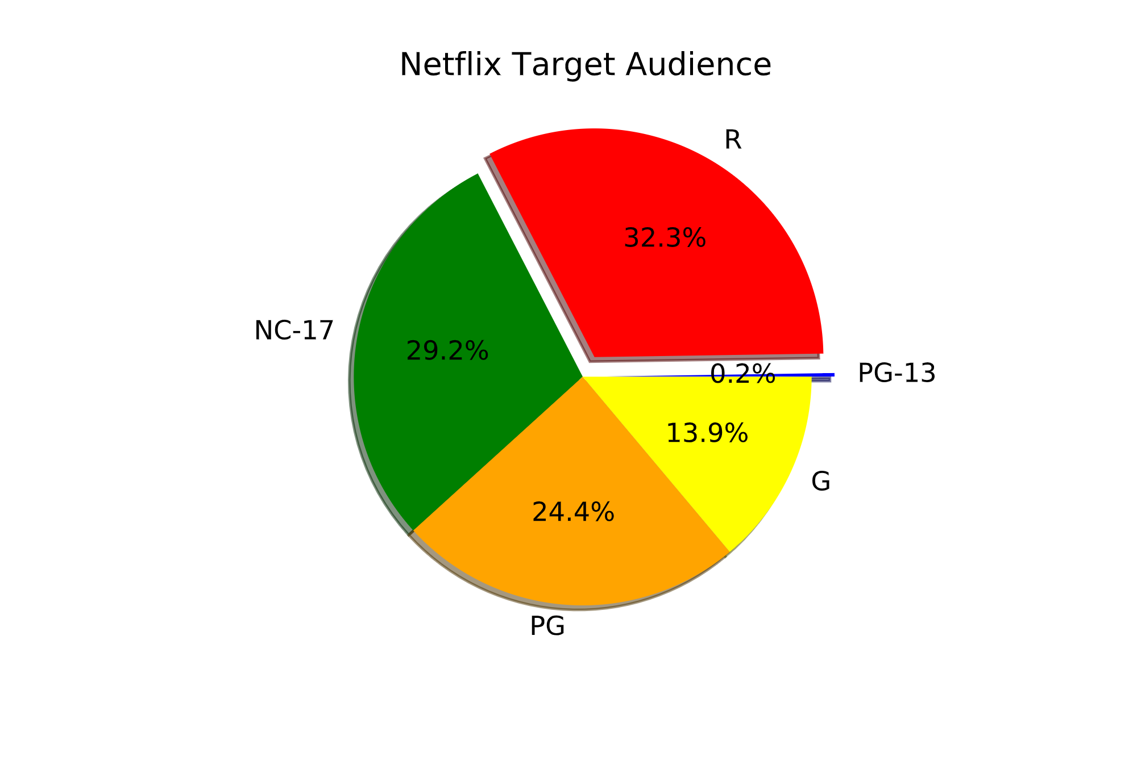

**When are most of the shows/movies produced?**

For starters, Prime has the most shows with 2,144, followed by Netflix with 1,931, then Hulu with 1,754, and last is Disney+ with 180. In each dataset, for all platforms, it showed that the range of all shows produced were roughly between the years 1900 and 2020. Since most of the platforms only had a few shows produced in the early 1900s, we made the earlier ranges larger to add more to that data range. So, we made ranges from the years 1900 to 1949, 1950 to 1979, 1980 to 1989, 1990 to 1999, 2000 to 2009, and 2010 to 2020.

When looking at the graphs for these platforms, it showed something similar to an exponential trend with earlier years having little to no shows produced and more recent years having the majority of their shows produced. From that we saw that the majority of the shows were produced between 2010 and 2020 and this was a similar trend for all platforms. Within this range, Netflix and Hulu produced most of its shows in 2018, while Disney+ produced most of its shows in 2019, and Prime produced most of its shows in 2017. Disney+ specifically only became available last year, in 2019. This is a big reason why it has the least amount of shows (180) when compared to the other 3.

Since streaming services became more prominent within the last ten years, it's understandable why all these platforms have most of their shows being produced so recently. Especially within the last 5 years cable TV has been becoming less and less popular with the addition of all these streaming services. Also, it's crazy how a combination of all 4 can sometimes cost less than most cable TV providers.

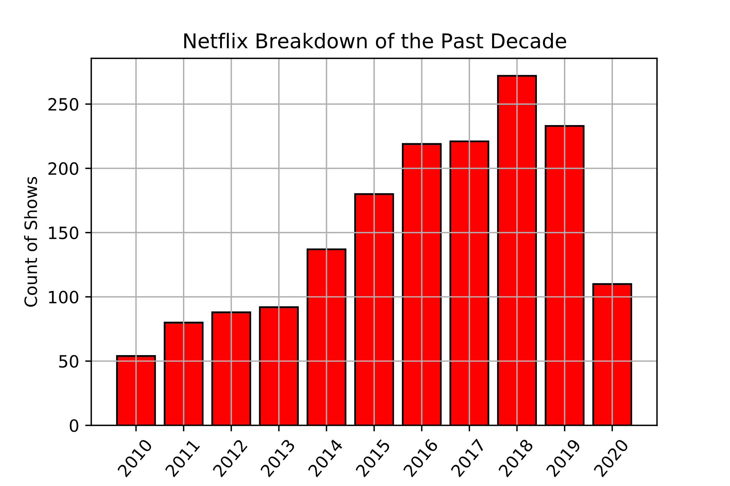

**Differences between IMDB and Rotten Tomatoes?**

Movie and TV fanatics know all about the ratings of IMDB and Rotten Tomatoes. The question is, which one should you look at when determining if a show or movie is worth watching? You should look at both because Rotten Tomatoes represents a percentage of critics who review a film positive while IMDB incorporates all the individual votes casted by critics and creates a score.

During our analysis, we tested to see if Rotten Tomatoes and IMDB had a positive correlation for their reviews. We anticipated there to be a positive correlation because ultimately they are watching the same film, just using different grading systems. Our theory was accurate when each streaming platform had a positive correlation around 0.5.

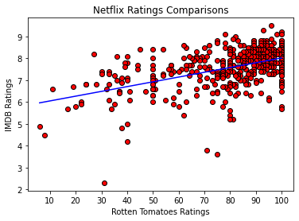

**Average ratings for each platform and their highest rated shows.**

The average rated IMDB shows for Netflix, Hulu, Disney+, and Prime are 7.16, 7.06, 6.92, and 7.18, respectively. The average rated Rotten Tomatoes shows for Netflix, Hulu, Disney+, and Prime are 78.32%, 78.29%, 81.17% and 77.21%, respectively. Even though “high” ratings do not necessarily mean better shows, if one were to choose a platform based on overall rating, then they probably should go with Prime based off of IMDB and Disney+ for Rotten Tomatoes. However, the ratings are so close that it really doesn’t matter which platform you choose. It’s all preference at that point, whether it’s age preference, genre, or time period.

* **Breaking Bad** is the highest IMDB rated Netflix show, with a rating of 9.5. **Avatar: The Last Airbender** is the highest Rotten Tomatoes rated Netflix show, with a rating of 100%.
* **Destiny** is the highest IMDB rated Hulu show, with a rating of 9.6. **Fullmetal Alchemist: Brotherhood** is the highest Rotten Tomatoes rated Hulu show, with a rating of 100%.
* **The Imagineering Story** is both the highest IMDB rated and Rotten Tomatoes rated Disney+ show with a rating of 9.1 and 100%, respectively.
* **Malgudi Days** is the highest IMDB rated Prime show, with a rating of 9.5. **The Planets** is the highest Rotten Tomatoes rated Prime show, with a rating of 100%.

**Summary of Statistics**

